https://theappliancepros.ca/blog/refrigerator-return-air-vent/

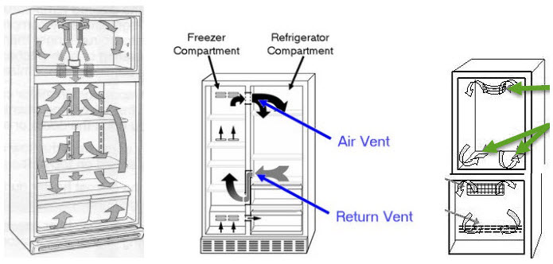

- PREDICTING AIRFLOW AND TEMPERATURE PATTERN INSIDE A REFRIGERATOR THROUGH CFD https://www.arpnjournals.org/jeas/research_papers/rp_2016/jeas_0716_4650.pdf

